**DESIGN AND IMPLEMENTATION OF AN IoT SMART ENERGY METER**

**WITH LOAD CONTROL**

BY

OLADIPO, ABDULLAH AKINWUMI

(EEG/2014/083)



A THESIS SUBMITTED IN PARTIAL FULFILMENT OF THE

REQUIREMENTS FOR THE AWARD OF BACHELOR OF SCIENCE IN

ELECTRONIC AND ELECTRICAL ENGINEERING

FACULTY OF TECHNOLOGY

OBAFEMI AWOLOWO UNIVERSITY

ILE-IFE, NIGERIA.

FEBRUARY 2020

# CERTIFICATION

I certify that this work was carried out by Oladipo, Abdullah Akinwumi EEG/2014/083 in partial fulfilment of the requirements for the award of the degree of Bachelor of Science (B.Sc.), in the Department of Electronic and Electrical Engineering, Obafemi Awolowo University, Ile-Ife, Nigeria.

__________________________________

SUPERVISOR

DR. (Mrs) F. OFFIONG

Department of Electronic and Electrical Engineering

Obafemi Awolowo University, Ile-Ife, Nigeria.

# ACKNOWLEDGEMENT

I start by acknowledging the unquantifiable help God has given me to complete this project and making the compilation of this report possible. I extend my gratitude to my family for their support financially and morally.

I am equally indebted to my very understanding and enviable project supervisor in person of

Dr. (Mrs) Offiong for her support and guidance from the beginning of this project to the end for she is always willing to go above and beyond in counselling and giving proper supervision.

Furthermore, I will be forever grateful to Taiwo Habeeb Adebiyi, Taiwo Hassan and Ajala Oladapo for all their technical advice and assistance. Finally appreciating the coordination of my project group mates and the entire EEE family, it has not just been a long ride but also an exciting one with them.

# 

# DEDICATION

To God Almighty for his grace and provision, my parents for their constant support, my siblings for their care and my friends for their assistance do I dedicate this report.

# **TABLE OF CONTENTS**

CERTIFICATION ii

DEDICATION iv

ACKNOWLEDGEMENT iii

TABLE OF CONTENTS v

TABLE OF FIGS viii

LIST OF ABBREVIATIONS ix

ABSTRACT x

CHAPTER ONE: INTRODUCTION 1

1.1 Background 1

1.2 Aim and Objectives 2

1.3 Justification 3

1.4 Scope 3

1.5 Report Outline 3

CHAPTER TWO: LITERATURE REVIEW 4

2.1 Smart Devices and Smart Home 4

2.2 Internet of Things (IoT) 5

2.2.1 IoT in building and home automation 7

2.2.2 IoT in transportation 7

2.2.3 IoT in agriculture 7

2.2.4 Factors to consider when building smart home system 8

2.2.5 Best automation products 9

2.3 Energy Monitoring System 12

2.4 Current Sensor 15

2.4.1 Alternating current (AC) 15

2.4.2 Direct current 16

2.5 ESP 32 Microcontroller 16

2.6 Web Application 22

2.6.1 Security concerns 23

2.6.2 Encryption 25

CHAPTER THREE: METHODOLOGY 27

3.1 Overview 27

3.2 Implementation of the Project 29

3.2.1 Energy monitoring system and management 29

3.2.2 Load control 31

3.2.4 Design of the web application 32

3.3 Technical Description 33

3.3.1 Monitoring and control circuit 33

3.3.2 Building of the Dashboard 36

CHAPTER FOUR: RESULTS AND DISCUSSIONS 37

4.1 The Hardware System 37

4.2 The Web Application 41

4.3 Summary 45

CHAPTER 5: CONCLUSION 46

5.1 Conclusion 46

5.2 Recommendation 46

REFERENCES 47

# 

# TABLE OF FIGURES

Fig 2.1: Basic IoT Functional Blocks 6

Fig 2.2a: Amazon echo plus……………………..……………………………………………11

Fig 2.2b: Nest learning thermostat……….…………………………………………………...11

Fig 2.2c: Ring video doorbell…………………..………………………………………….….11

Fig 2.3: System overview of an IoT based energy monitoring system…………………….......14

Fig 2.4: A Non-invasive AC Current Transformer SCT-013-00 17

Fig 2.5: ESP 32 System architecture 18

Fig 2.6: An ESP32 device 19

Fig 3.1: Block diagram of smart energy meter with load control……………………….……28

Fig 3.2: Circuit diagram of the current measurement with SCT-013-000………………....….34

Fig 4.1: The testing phase of the project featuring the dashboard………….…………….…...39

Fig 4.2: The final hardware system featuring the current sensor in use………………………40

Fig 4.3a: Signup page…………………………………………………………………………42

Fig 4.3b: Login page………………………………………………………………….….…...42

Fig 4.5: Dashboard…………………………………………………………………….……...43

Fig 4.6: Data Log……………………………………………………………………..…........44

# 

# LIST OF ABBREVIATIONS

DC: Direct Current

IP: Internet Protocol

IoT: Internet of Things

AC: Alternating Current

CT: Current Transformer

CSS: Cascaded Style Sheet

AMR: Automatic Meter Reading

HTTP: Hypertext Transfer Protocol

ADC: Analog to Digital Controller

AMI: Advanced Metering Infrastructure

VCC: Voltage at the Common Collector

MQTT: Message Queuing Telemetry Transport

# ABSTRACT

The Internet of Things (IoT) is the network of physical objects, devices, vehicles, buildings and other items which are embedded with electronics, software, sensors, and network connectivity, thus enabling these objects to exchange and collect data over the internet with the aim of interaction, connectivity and data sharing. It has several potential applications and can be implemented in areas like Home Automation, Energy management, Medicine, Agriculture, Transportation etc. offering several features like economical use of energy to protection, monitoring and safety.

This project focused on implementation of a low cost and effective smart energy meter enabling load control with a web application interface harnessing the power of internet as a means of communication.

The project was implemented with current sensors for monitoring and calculating energy consumption as well as cost; ESP-32 microcontroller for gathering data, controlling attached devices and sending data over to the internet using hotspot from phone as gateway. On the user’s end, a web application is being built which displays necessary data to the user and give user the ability to send control to his devices from anywhere in the world.

The project will enable users from homes and offices to have immediate and remote access to their devices, monitor and economise energy consumption and be alerted in real time for any overly unexpected consumption. Thereby, making buildings smart, interactive and more secure.

# CHAPTER ONE

# INTRODUCTION

## Background

According to Bhat et al. (2017), Internet has changed human life by providing facility of connecting anyone with anyone at any instance, from anywhere to other places. Similarly, the advancements in the fields of hardware such as processors, sensors, transmitters, receivers have led to rapid development in the field of communication in turn changing the pace of our every-day life. So, to expand the services of Internet, Internet of Things has been introduced. Though a relatively new concept of it is gaining fame in the recent endeavors of technology.

The **Internet of things** (**IoT**) is the extension of Internet connectivity into physical devices and everyday objects. Embedded with electronics, Internet connectivity, and other forms of hardware (such as sensors, these devices can communicate and interact with others over the Internet, and they can be remotely monitored and controlled.

IoT aims on connecting physical devices of the world like Ventilation system, Fan, TV, lights, sensors, smart watches, fitness band etc. over a network so that they can communicate with each other and take decisions intelligently.

Consider an example, if you leave your electrical oven on at home baking while going out early in the morning and just having a sensor in it that will give you a notification via an app when the set temperature has been reached then it just turns off or you just turn it off through the app remotely. Also, imagine a system that would compute the energy usage at your home compare it with the expected set value within a period of time, thereby economizing and increasing the efficiency of the energy supply in homes by giving you on the go access to power, energy, cost, and all other metrics data to monitor energy. These are all concerns of IoT smart meter of which this project was fundamentally built on.

Thus, IoT is changing how we interact with things around us and rather how they interact with each other to make life simpler and more convenient and thus this power should be harnessed to improve quality of lives for humanity.

## Aim and Objectives

The aim is to develop a low cost and effective smart Energy meter with load control.

The objectives are:

* To identify various components or modules that make a Smart Meter
* To bring them together to form a Smart Energy meter and incorporate Load Control
* To build a web application as user interface

## 1.3 Justification

The current system of the Energy meter only provides access for the consumer and provider to display read values on meters while the current trend of home automation system or general smart system likewise only incorporates Bluetooth or IEEE 802.11 (Wi-Fi) which has limited coverage range; about 10 m and 30 m respectively. As an improvement of the current trend, this system has an all-inclusive function that will monitor and manage energy and give user access to remote load control over the internet which makes it convenient to be controlled from anywhere in the universe where there is network connection (i.e. not limited by distance).

## 1.4 Scope

The project focused on making buildings smarter only in the areas of energy monitoring and load control. A web application was developed to be used as user interface considering its vast popularity in market, no new website whatsoever was hosted but rather an already existing free server was used which is MQTT protocol based. This development is not planned to be directly disbursed in home, thus few loads like lighting points, and few AC load were prototyped but provides a good foundation for scalable development.

## 1.5 Report Outline

This report is organized in five chapters. Chapter one discusses the Background information on the project, Aim and Objectives, Justification, Scope and provide this Report outline, Chapter two discusses the state of IoT Smart Energy Meter and the review of existing Smart Meter while providing insights into the technology and components of IoT system, Chapter three discusses the method that was used in achieving the objectives and aim, Chapter four presents Test, Result and discussion and finally, Chapter 5 presents conclusion and recommendation.

# CHAPTER TWO

# LITERATURE REVIEW

## 2.1 Smart Devices and Smart Home

Many times, when people think of smart devices, what comes to mind is smart home or home automation but in the real sense, it entails several other applications ranging from the common home automation to agriculture, medicine, transportation etc.

As for smart home, it is stated in Wikipedia that a **smart home** or **smart house** will have a home automation system which will control lighting, climate, entertainment systems, and appliances. It may also include home security such as access control and alarm systems. When connected with the Internet, home devices are an important constituent of the Internet of Things.

Smart home-enabled devices can include appliances like refrigerators, washing machines, dryers, and toaster ovens, as well as heating and air conditioning units and lighting devices. As stated in Webopedia, some examples of smart home-enabled electronic devices are audio and video entertainment systems, camera and security systems, and computers, laptops and other electronics mobile devices.

A Smart home consists of four major parts:

* The service platform
* The smart devices
* Home gateway
* Home network

A major component of smart system that make devices smart is internet which creates connectivity between devices and users and between one device to another. The concept behind this is referred to as IoT. Under section 2.2, few examples from the best home automation that currently exists.

## 2.2 Internet of Things (IoT)

As defined by Wikipedia, The **Internet of things** (**IoT**) is the extension of Internet connectivity into physical devices and everyday objects. Embedded with electronics, Internet connectivity, and other forms of hardware (such as sensors), these devices can communicate and interact with others over the Internet, and they can be remotely monitored and controlled.

The current number of internet-connected devices as at 2018 was more than the number of people who exist on earth. CISCO reports that by the year 2020 there will be about 30 billion connected devices, we are currently at about 23.14 Billion (Mwaura, 2018).

The concept of IoT was to spread the smartness of devices beyond normal computers, laptops, and mobile devices and transfer the same to traditionally dumb devices. IoT converts dumb devices to smart devices by adding the capability to network, communicate and share data. So say one has a fridge situated in one’s house or in another city that stores fish, with IoT it could be able to tell what capacity of fish left and also order the same from nearest food store or somewhere else, with one’s permission. Some of the applications will be highlighted. Fig 2.1 shows the basic IoT functional blocks



**Fig 2.1**: Basic IoT Functional Blocks (Patnaikuni, 2017)

### 2.2.1 IoT in building and home automation

With IoT, it is possible to monitor and control mechanical and electrical systems in various buildings using one single system. The main advantages that are attributed to the interconnection of devices include efficient energy management systems for buildings and hence promotion of a greener economy, massive data collection which could be a major driver for data science and machine learning, real-time monitoring which provides for efficiency and accuracy when monitoring remote systems.

### 2.2.2 IoT in transportation

Using IoT in autonomous driving could mean zero or close to zero traffic in the future smart cities as the vehicles could communicate with sensors and draw alternative routes to ease traffic. The data received from the vehicles could also be used to calculate the routes that would lead to more energy saves for the vehicles (electric). IoT could also be used to solve problems such as city parking, traffic lights control, and even toll collection services.

### 2.2.3 IoT in agriculture

IoT through use of various sensors is currently being actively used in agriculture to monitor humidity, temperature, pH levels, wind speed, rainfall and even pest infestation in crops. The sensors are integrated with mobile applications and cloud platforms and this becomes essential in the automation of the farming practice.

**Generally** for IoT; truth be told, the truth is still quite far from being achieved and might not get to it soon but the reality is that we are slowly starting to see the onset of a future that have long been dreamt about: Smart televisions that can talk back to us, smart speakers, smart controls that can do anything from controlling our home lighting to increasing the temperatures of our rooms and talking smart speakers. All the above implementations explain how IoT is slowly gaining pace. “Mind you we are just at the beginning of an era which might be more interesting than what we are prepared for” (Mwaura, 2018).

### 2.2.4 Factors to consider when building smart home system

Starr (2020) stated that there are three basic factors to consider when building a smart home:

* Usability
* Network security
* Power outages

**Usability**

Since smart homes are designed to provide ease and efficiency, compatibility to other devices within the home must be a great factor to consider. Additionally, few important questions need to be answered like: Will it easily connect to other smart electronics? Is it easy to use? Does the device save you time and money? Answer to these questions will improve the ease and efficiency of the smart device being purchased.

**Network security**

Since smart home relies solely on network connection, two things are paramount about the network. A network strong enough to support daily activities and a secure network connection to store gadget’s data safely.

**Power outages**

Since there will always be power outages particularly in developing countries like Nigeria, a device that factors in power outages should be considered otherwise manual backup options like mini-grid supply should be considered to keep the home running normally every hour of the day.

### 2.2.5 Best automation products

Following examples are few top-rated examples of best automation products that currently exist **according to safety.com** (2020)**:**

1. Amazon echo plus
2. Nest learning thermostat
3. Ring video doorbell

Below is the brief description of stand-out features of each of them:

1. **Amazon echo plus**

It is an all-in-one smart home hub with the power to play music, act on voice command and connect you to other rooms like an **intercom**, it further has the power to connect and control home’s devices including light bulbs, smart locks and security cameras.

Fig2.2a shows the look of Amazon echo plus.

1. **Nest learning thermostat**

This is one of the most popular smart home electronics used to automate temperature in the house by controlling each room’s temperature using Nest Temperature Sensor through the thermostat or by the user through the mobile app, automatically detects when you are away from home and reduces the temperature and finally use Bluetooth low energy to control the thermostat while saving energy.

Fig 2.2b shows Nest learning thermostat

1. **Ring video doorbell**

It uses a crystal clear high-definition (HD) video camera to monitor who is at the door or window at night, this can trigger alerts using the mobile ring app. It is powered by an easy to remove battery pack to charge the battery without detaching the doorbell and it has high weather resistance to continue working through harsh weather conditions from about -5 to 120 degrees Fahrenheit. Shown in fig 2.2c is an example ring video doorbell.

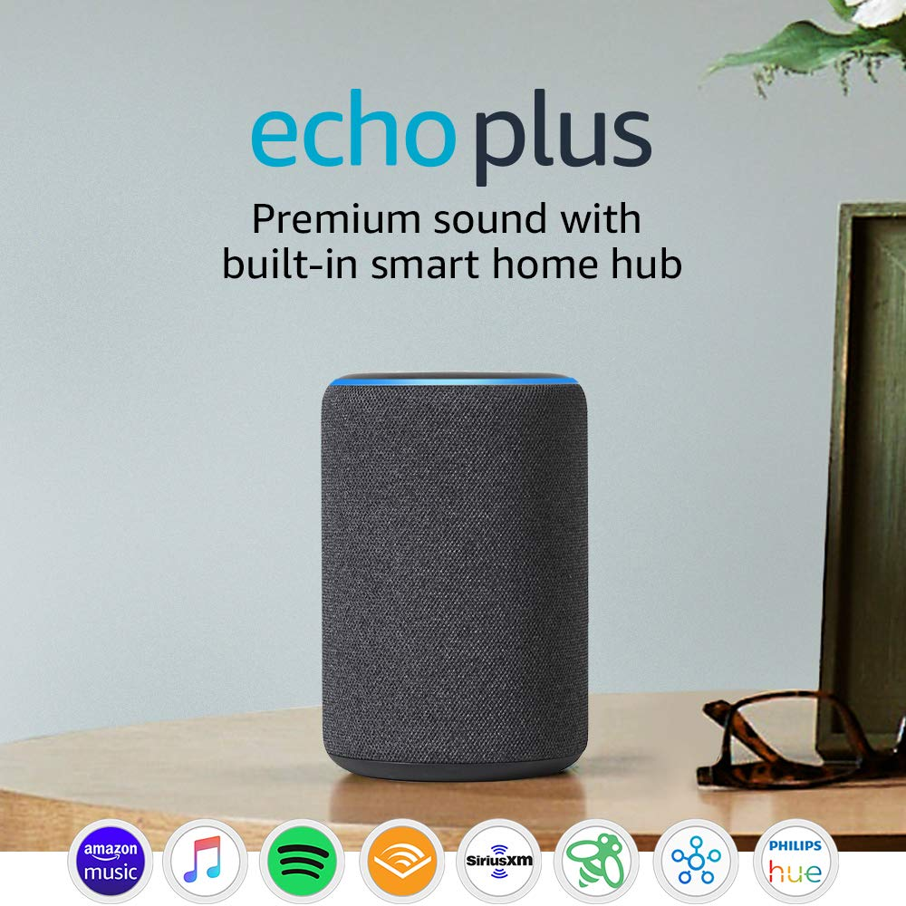 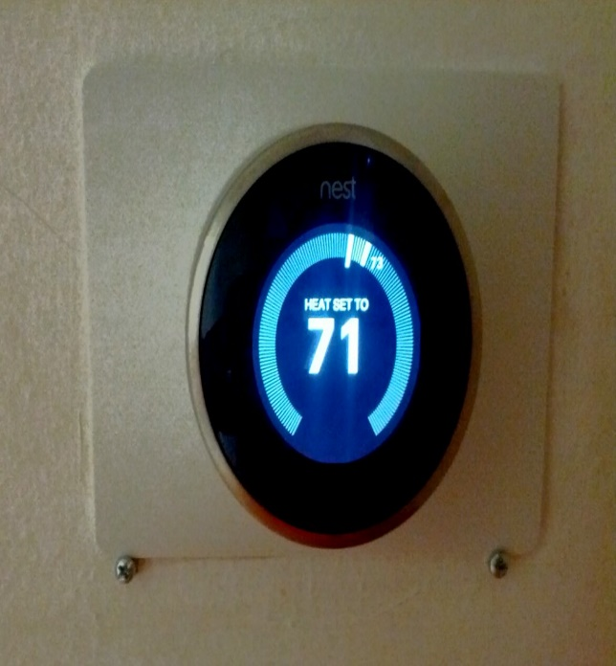

(a)(b)

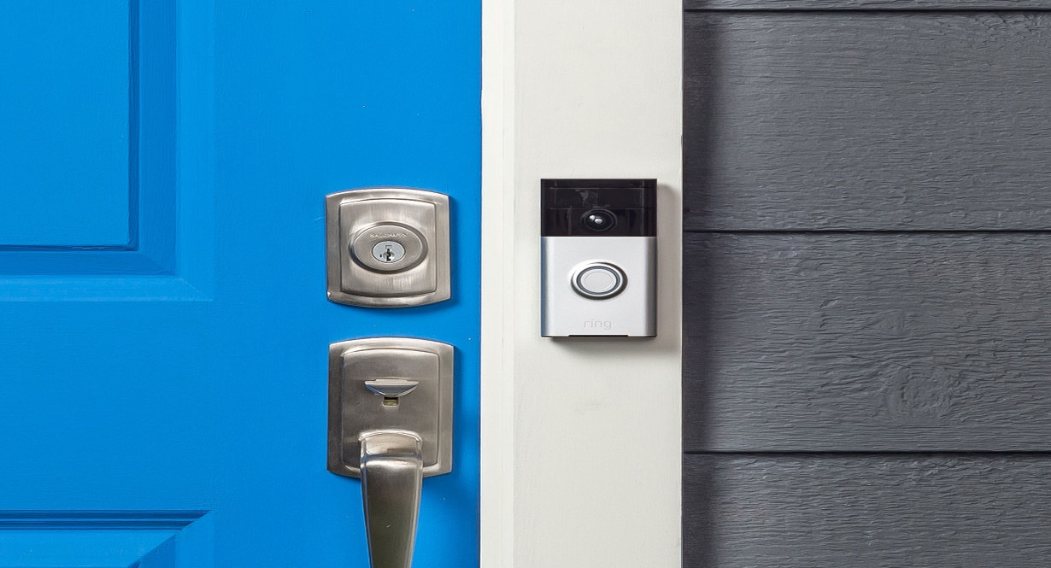

(c)

**Fig. 2.2 (a)** Amazon echo plus, **(b)** Nest learning thermostat and **(c)** Ring video doorbell

## 2.3 Energy Monitoring System

In recent time, electric energy consumption growth has risen significantly and thus, needed greatly is increased energy supply in the coming decades due to increasing population and economic development. This is leading to a demand-supply deficiency (Amin and Wollenberg, 2005). According to Chooruang and Meekul (2019), in many developed countries, automatic meter reading (AMR), advanced metering infrastructure (AMI) or smart energy meter with real-time energy information report have been implemented at the household level. Thus, consumers will be able to see their usage in real-time, eventually encouraging them to use less energy to save money. In addition, studies have suggested that more energy can be saved or decreased in household level with real-time energy consumption feedback as compared to conventional indirect feedback like monthly bills (Taktak and Rodriguez, 2017). However, those smart meters are usually high cost and require large amounts of Investments on communication medium infrastructure; hence in many developing countries, these might not be an efficient and affordable solutions.

In construction, an energy monitoring system makes use of noninvasive CT (current transformer) sensor, energy measurement chip and microcontroller for measuring the voltage, current, active power and accumulative power consumption of load. The simple principle of application of this system is that it uses current transformer to measure the current consumed by devices in the building, then the microcontroller with the pre-written code does the computation of power and energy using the known parameters which are voltage and time. Thereby, producing record of the energy consumed within the building.

In an IoT based energy monitoring system, the measured data will then be submitted to server via communication protocol like MQTT or HTTP in JSON (JavaScript Object Notation) format of which further processing can then be carried out on it. This principle is the backbone of the construction of smart meters. Fig 2.3 shows a system overview of an IoT enabled energy monitoring system designed by Chooruang and Meekul (2019) which as a monitoring node for the load making use of PZEM-004T Current Transformer based energy meter and ESP micro controller as the Wi-Fi node, then a local MQTT server, a router, internet medium and application base user interfaces.

**Energy calculation**

Having obtained the current reading with the known voltage, the power consumed in watt can be calculated by

So, the energy consumed per day in kW can then be obtained by:



**Fig 2.3**: System overview of an IoT based energy monitoring system (Chooruang and Meekul, 2019)

## 2.4 Current Sensor

As defined by Wikipedia (2019), a current sensor is a device that detects electric current in a wire and generates a signal proportional to that current. The generated signal could be analogue voltage or current even a digital output which can now be used to display the measured current in an ammeter or can be stored for further analysis in a data acquisition system, or can be used for the purpose of control. Current transformers have a primary winding with few turns (or a single conductor) through the core opening and a secondary winding, which should ideally be short-circuits, but it has some small burden. The core is usually ring-shaped, either wound or high permeability tape for precise, low frequency devices or made from ferrite for high frequency devices. The current transformer amplitude and phase error depend on the core materials and size, winding geometry, amplitude and frequency of the measured current, and the value of the burden which is sometimes in the form of current-to-voltage converter (Ripka, 2004).

This sensed current can either be alternating or direct;

### 2.4.1 Alternating current (AC)

In AC, the electric charge changes direction periodically, the voltage also periodically reverses because of the periodic changes in the direction of the current. AC is used to deliver power to houses, office buildings, etc.

To generate AC, a loop of wire is spun inside a magnetic field which induces a current along the wire, the rotation of the wire can come from any number of means; a wind turbine, a steam turbine, flowing water, and so on. The voltage and current alternates on the wire because the wire spins and enters a different magnetic polarity periodically. AC are mostly always used in home and office outlets because generating and transporting AC across long distances is relatively easy and less energy is lost in electrical power transmission at high voltages (over 110 kV).

### 2.4.2 Direct current

This is easier to understand than AC because rather than oscillating back and forth, DC provides a constant voltage and current. It can be generated in a number of ways, this includes An AC generator equipped with a device called a “commutator”, use of rectifier that converts AC to DC or batteries that provide DC which is a generated from a chemical reaction inside of the battery.

Fig 2.4 shows an image of a current sensor that makes use of current transformer.

## 2.5 ESP 32 Microcontroller

The ESP32 Wi-Fi Module is an extremely capable wireless programming microcontroller board, it is a self-contained SOC with integrated TCP/IP protocol stack that can give any secondary microcontroller access to Wi-Fi network. The ESP32 is capable of either hosting an application or offloading all Wi-Fi networking functions from another application processor and therefore more suitable to be used as a sensing node that is capable to sense the data from various wirelessly connected IoT sensor nodes and send data to the central server.

According to Baig et al. (2015-2016), each ESP32 module comes pre-programmed with an AT command set firmware, meaning, one can simply hook this up to an Arduino device and get about as much Wi-Fi-ability as a Wi-Fi Shield offers. The ESP32 module is an extremely cost-effective board with a huge, and ever-growing community. Fig 2.5 shoes the architecture of an ESP 32 and Fig 2.6 shows a typical ESP32.

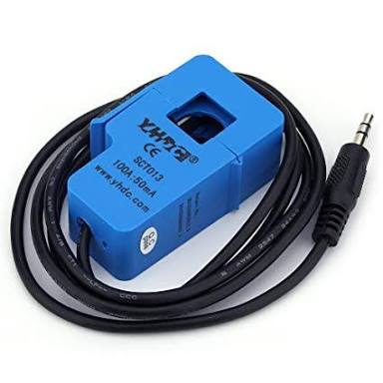

**Fig 2.4**: A Non-invasive AC Current Sensor SCT-013-000 (Open Energy Monitor, n.d.).



**Fig 2.5**: ESP 32 System architecture (Maier et al, 2017)

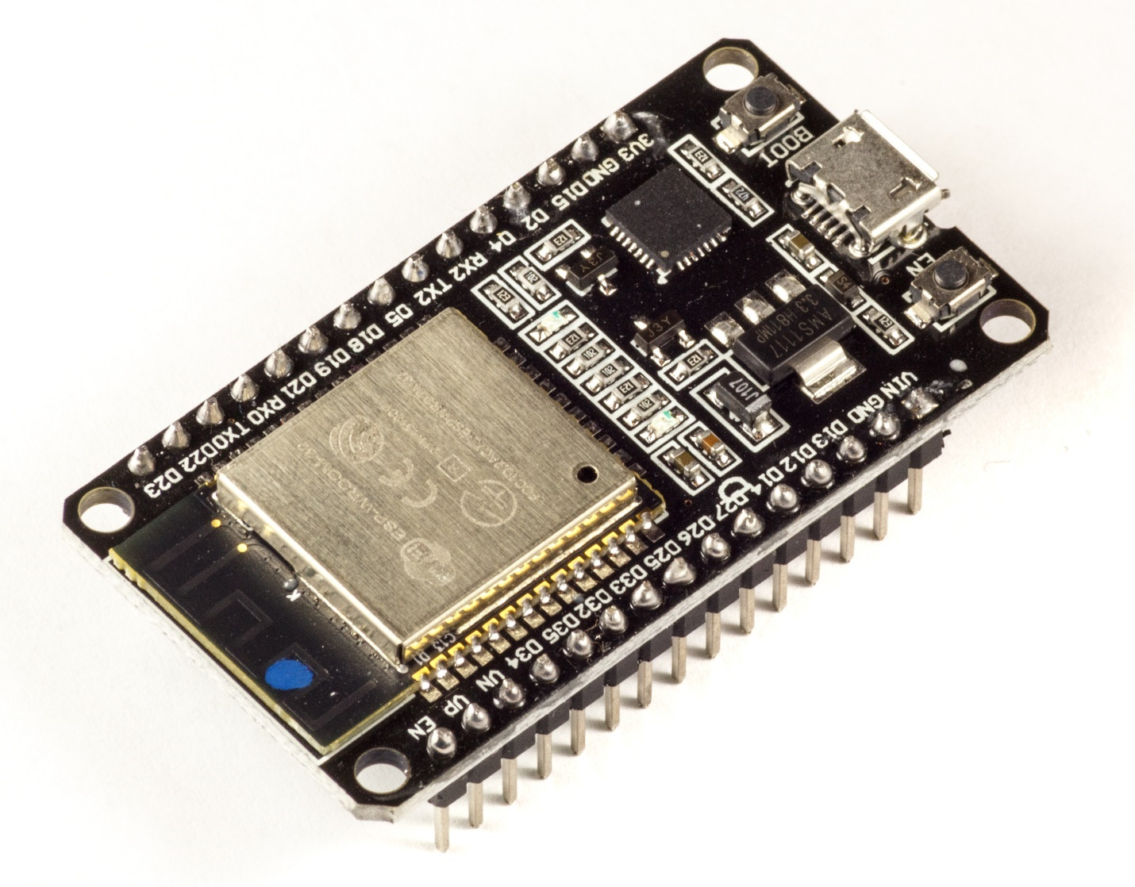

**Fig 2.6**: An ESP32 device (Mates, 2020)

Similar modules for other microcontrollers are often used for tests and prototypes or by hobbyists. Table 1 compares some of the details of the microcontrollers for IoT design:

**Table 1**. Microcontrollers for IoT design (Maier et al., 2017)

|  |  |  |  |  |  |  |  |  |
| --- | --- | --- | --- | --- | --- | --- | --- | --- |
| |  |  |  |  | | --- | --- | --- | --- | | Chip  (Module) |  |  |  | | ESP32  (ESP-ROOM-32) | ESP8266  (ESP8266-12E) | CC32  (CC3220MODSF) | Xbee  (XB2B-WFPS-001) |
| **Details:** | | | | |
| `CPU | Tensilica Xtensa LX6 32 bit Dual-Core at 160/240 MHz | Tensilica LX106 32 bit Dual-Core at 160 MHz | ARM Cortex-M4 at 80 MHz | N/A |
| SRAM | 520 kB | 36 kB available | 256 kB | N/A |
| FLASH | 2MB (max. 64MB) | 4MB (max. 16MB) | 1MB (max. 32MB) | N/A |
| Voltage | 2.2V to 3.6V | 3.0V to 3.6V | 2.3V to 3.6V | 3.14V to 3.46V |
| Operating Current | 80 mA average | 80 mA average | N/A | N/A |
| Programmable | Free (C, C++, Lua, etc.) | Free (C, C++, Lua, etc.) | C (Simple Link SDK) | AT and API commands |
| Open source | Yes | Yes | No | No |
| **Connectivity** | | | | |
| Wi-Fi | 802.11 b/g/n | 802.11 b/g/n | 802.11 b/g/n | 802.11 b/g/n |
| Bluetooth® | 4.2 BR/EDR + BLE | 2 | 2 | 1 |
| **I/O** | | | | |
| GPIO | 32 | 17 | 21 | 10 |
| SPI | 4 | 2 | 1 | 1 |
| I2C | 2 | 1 | 1 | - |
| PWM | 8 | - | 6 | - |
| ADC | 18 (12-bit) | 1 (10-bit) | 4 (12-bit) | 4 (12-bit) |
| DAC | 2 (8-bit) | - | - | - |
|  | | | | |
| Size | 25.5 x 18.0 x 2.8 mm | 24.0 x 16.0 x 3.0 mm | 20.5 x 17.5 x 2.5 mm | 24.0 x 22.0 x 3.0 mm |
| Prize | £8 | £5 | £16 | £23 |

## 2.6 Web Application

According to Hosting facts research, there are **4.1 billion Internet users** in the world as of December 2018, this is compared to 3.9 billion Internet users in mid-2018 and about 3.7 billion Internet users in late 2017; Asia has the most internet users of all continents while China has the most internet users of all countries with number of internet user being more than the combined population of U.S., Japan, Russia and Mexico (Internet Stats and Facts, 2019). So, billions of people around the world are internet users with that number increasing every day which means all these people can easily launch there browsers and access web applications.

Moreover, to try out web app does not require energy but just a simple click compared to native app, it has effective designs because it is platform independent compared to native where you have to cater for android separate from iOS.

Thus, it makes sense that web apps are more often than not the the first stop channel for accessing online business, e-commerce and some IoT devices, due to the ease of developing them. Also, web has a very flexible platform independent of operating system for transmitting data as well; with a single device and app, IoT devices can be managed and monitored.

Web as well as Mobile apps have made life easier in a variety of ways,they now have power to link lots of devices and exchange information, mentioned below are some cool areas where mobile apps are leveraging IoT.

* Wearables
* Healthcare and medicine
* Blockchain technology
* Smart homes
* Agriculture
* Retail
* Smart cities etc.

However, there are security concerns as the more devices added to a network, the more vulnerable it is to security threats. It is recorded that over 90,000 websites are hacked everyday (Internet Stats and Facts, 2019). So, both the IoT devices and the apps must be secure by design. Operating systems must be updated as at when due for not patching when necessary can pose a huge security risk.

### 2.6.1 Security concerns

In a traditional software development enterprise, people are vetted, badged, and trained on security best practices but still a certain degree of error can be found. A better approach to the mitigate error and security breach is to go on the offensive treating every interaction as a secure one. The following security and confidentiality processes are employed to make sure that nothing is left unchecked and that IoT customers or users are always protected from security breach through the app (Morris, 2017):

**Security and IP screening software**

Most software and data security breaches are mostly unintentional, so there is need to embrace technology to ensure no code, design or algorithm go unchecked. Starting with the simple fact that secure channels must always be used to transfer any IP enabling systematically tracking and monitoring of the lifecycle of the customer’s digital assets.

In advanced software firms, a combination of best-of-breed static analysis code scanning and IP screening combined with in-house technology is being used. At some level, artificial intelligence and advanced heuristics is used to certify security and adherence to standards, best practices and authenticity of the code.

**Process and code reviews**

Apart from having a software completely developed, putting processes in place to ensure things according to a plan is very important. Atomization of code is necessary in order to protect customer’s privacy and remove single points of failure such that no one person is physically able to connect independent pieces to do something nefarious.

**Contracts, rules, and regulations**

The conventional security measure that has been around for ages is only contract, whereas a contract should be the lowest on the totem pole of all the things a business can do to protect their customers. This signed piece of paper as contract only provide a single layer of security, they are good to have and very necessary but no longer enough in this digital age because going to the contract to resolve an issue is already too late. When developers’ community submit to a challenge, there should be extensive rules and regulations that are far more specific by adhering to them in application, referencing them and enforcing them on every interaction that shares or produces IP. Most companies apply to enforce them twice: at the time of hire and at the time of exit.

**Conclusively**, businesses do not to sacrifice innovation for security. Through secure software channels, IP screening tools, peer reviews, and code scans, it is most close to reality to deliver the safest possible software experience for the customers while also preventing the most innovative method of technology delivery.

### 2.6.2 Encryption

Encryption is the process of encoding a message or information in such a way that only authorized parties can access it and those who are not authorized cannot. Encryption does not itself prevent interference, but denies the intelligible content to a would-be interceptor. In an encryption scheme, the intended information or message, referred to as plaintext, is encrypted using an encryption algorithm, a cipher generating cipher text that can be read only if decrypted. For technical reasons, an encryption scheme usually uses a pseudo-random encryption key generated by an algorithm. It is in principle possible to decrypt the message without possessing the key, but, for a well-designed encryption scheme, considerable computational resources and skills are required. An authorized recipient can easily decrypt the message with the key provided by the originator to recipients but not to unauthorized users. Since the project involves about transmitting energy and safety condition of client homes which is a sensitive information, hence the need for encryption.

**Types of encryption**

Encryption is majorly of two type, they are symmetric and asymmetric scheme

1. **Symmetric scheme**: In this scheme, the encryption and decryption keys are the same. Communicating parties must have the same key in order to achieve secure communication. it is generally categorized as being either Stream Cipher or Block cipher. **Stream cipher is** a symmetric encryption algorithm that processes the data a bit or a byte at a time with a key resulting in a randomized cipher data or plain data while **Block cipher** is a deterministic algorithm operating on fixed-length groups of bits, called blocks. The most common Symmetric scheme is Advanced Encryption Standard (AES). The main advantage of the scheme is that it can encrypt large data compared to asymmetric scheme. However, this scheme has a drawback of safe distribution of key. If the secret key is known by the intruder, all the message transmitted can be easily decoded.
2. **Asymmetric scheme: is** a modern branch of cryptography also known as public-key cryptography in which the scheme employs a pair of keys (a public key and a private key). The public key is published for anyone to use for encrypting messages while only the receiving party has the private key for decrypting the message sent. The most common Asymmetric scheme is Rivest-Shamir-Adleman (**RSA)** Algorithm, a public-key encryption algorithm and the standard for encrypting data sent over the internet.

# 

# CHAPTER THREE

# METHODOLOGY

## 3.1 Overview

The smart energy meter with load control provides an energy monitoring system that keeps track of the real time consumption of power and energy used by the whole building, it then provides the user with access to control (switch on/off and reset) these appliances at ease with a web application, this could be due to the user’s need at a particular time or prompted to the user by the smart meter as a feedback in a demand to conserve energy or to minimize cost (e.g. the smart meter notifies the user via the app when power consumption has exceeded the set value or when the set value for unit consumption is about to be exceeded or when cost is running higher than normal).

All these data are being sent from the controller to user’s dashboard via MQTT protocol and can easily be viewed and interacted with on the dashboard.

Also, my Arduino code is hosted at <https://github.com/abdulloooh/smart_home_system>.

The block diagram of smart energy meter is presented in fig 3.1

Current sensors

ESP32 Microcontroller

LM 35

Smoke sensor

PIR

CLOUD

Loads (relay controlled)

Web app

**Fig 3.1**: Block diagram of smart energy meter with load control.

## 3.2 Implementation of the Project

The implementation of the project is categorized into three sections:

1. Energy monitoring and management
2. Load control
3. Design of the web application

### 3.2.1 Energy monitoring system and management

This module is implemented such that at any point in time, the system measures the current, calculate instantaneous power and total power since the inception of its use then sends the data to user’s dashboard storage online, this corresponds to the monitoring part.  
As a means of managing the consumption, user can give several descriptive inputs which include:

* Target consumption
* Unit cost
* Reset

**Target consumption**

The system receives any of this message anytime user injects the values; As for target consumption, the system keeps the current energy value for that session as the initial value once a target is set and start calculating the session consumption and the unit left to be consumed based on the target set while also keeping track of the total consumption in the background. Thus, two important variables are **total consumption** and **session consumption,** the former is overall or cumulative consumption while the latter is timed e.g. Monthly as used by many post-paid meters in Nigeria. Mathematically,

When session unit left = 0 or when session consumption = target consumption, the set value has been exceeded and then it alerts the user and the user can take the action to shut down the consumption or recharge more. As a bonus, it calculates percentage usage for each session so the user can see it as 80% has been consumed and 20% (say) left which is more intuitive instead of 76units used and 22 units left (say). Finally, the target consumption can be changed at any point in time if the user really needs to, it only requires setting another value and the system adjusts itself to the changes.

**Unit cost**

This system is also built such that it can be used for billing because it does the cost calculation automatically and user can get the cost of consumption out of the box on the dashboard, it provides an input box on the dashboard where user enters the current cost per unit consumption depending on user location or Government tariff at that particular time. Once this is set, it is sent to the controller which records the value and does the calculation as follows:

Recall the two important variables mentioned in the previous heading are total energy and session energy where one gets the cumulative of all usage while the other gets for an actual session e.g. weekly or monthly or annually.

Both cost values are continuously updated to the user dashboard and user can keep track of his expenses as well as sets limits for consumption (if needed). Also, this unit cost can be updated at any time and the system will automatically adjusts itself.

**Reset**

This as expected is to issue a complete refresh command to the system to restore all the previously set values or commands and roll back to the default state. This is particularly needed if user runs into any form of configuration error or malfunctioning of the system as there are always exceptions. A simple button is provided on the dashboard which can be clicked, and the system gets reset instantly.

### 3.2.2 Load control

Having ensured that the energy is being monitored and managed, a load control scheme is introduced into this system which serves the purpose of home automation, however with user control. In other words, the web application gives an interface where the user can easily issue control to the connected home appliances and thus change state from ON to OFF or vice versa. This however works completely independent of the energy monitoring and management system thus none affects the other.

Once the control is sent from the user, message is sent to the microcontroller over the internet, the controller sets its output which is the input to the relay high and then changes state from NC to NO or NO to NC as required.

In this project, four test loads are used which are two 13A sockets and two AC electric bulbs. Therefore, user has access to 4 different controls button each corresponding to its load and they all work independently.

The protocol of communication between the user’s command and the microcontroller is **MQTT**, there exists a **broker** which user publishes to and the controller subscribes to; the broker then performs the handshake between both ends to communicate the values.

### 3.2.4 Design of the web application

The application developed is a web app and this is due to the vast number of internet users in world market coupled with the ease and flexibility that accompanies it.

It has a setup page where user will create an account from start with strong security key, the account setup is bind with the smart meter system. Thus, every user must have distinct hardware system tied to his dashboard, this is to ensure perfect encryption and security of data and control to the home.

The interface consists of the following as earlier mentioned and described:

* Buttons (ON/OFF switch for load control).
* Power gauge
* Energy meter (total unit consumption and session unit consumption)
* Cost meter
* Input box (for cost per unit and target consumption)
* Reset button

## 3.3 Technical Description

This section briefly describes the technical details of the monitoring and control circuit as well as building of the dashboard.

### 3.3.1 Monitoring and control circuit

Non-invasive AC current sensor was used because it is a good way to measure real consumption without altering the electrical composition of the elements to be analysed, it works by magnetic induction so that the field generated in the cable used to power the device induces a current in the transformer integrated in the sensor. There are variety of sensors that can be used but the chosen one is *SCT-013-000* which has a maximum input current of 100A and corresponding output current of 50mA. This is sensor is chosen because it does not have an integrated resistance allowing us to adjust the measuring range in which we work, also it has the capacity for wide range of input current up to 100A, thus fitted for home use.

The SCT-013-000 circuit diagram for measuring current with the SCT is shown in fig 3.2.

**Note:** The terminal of SCT are connected to INPUT1 and VIRTUAL GND.

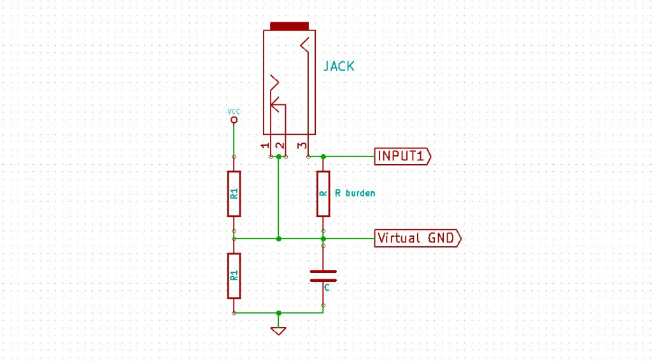

**Fig 3.2**: Circuit diagram of the current measurement with SCT-013-000

Being an AC measurement with an ESP, there was need to create a virtual ground by a voltage divider input to the ESP was now measured relative to, the value of R1 and R2 must be the same. 5V from the ESP was supplied to VCC and thus the reference is at 2.5V. This is necessary because output of SCT is AC which will be oscillating, and we can only measure positive values with highest amplitude being +2.5V.

**Note:** since ESP’s ADC can only measure up to 3.3V while 5V was used to power the VCC, the maximum measurable current in this case will be

From specification, the turn ratio of this device is 2000:1,

So,

Then choosing burden resistance R burden after much iteration (to get best accuracy) to be 3300ohms. Then,

since ESP uses 12bits equivalent to 4096.

## 3.3.2 Building of the Dashboard

The dashboard again is the user interface for the user to set parameters like unit cost and target energy consumption, monitor power, energy and cost and issue command to switch the home appliances.

The dashboard was built with web technologies including CSS to customize the design and **Ubidots** platform to host the app and provides out of the box utilities like notifications and Data visualization. Notification to the user when a set value is exceeded while visualization to view the log in graphical form so it can be analysed, and reasonable deductions can be obtained.

In the result section, the dashboard and graphical log of power consumption were shown in figs.

**In conclusion,** maximum effort and caution was made to get the system fully functioning and the result is impressive as discussed in the result section.

# CHAPTER FOUR

# RESULTS AND DISCUSSIONS

The project was completed with a fully functioning hardware system to measure current, control four prototyping loads (2 electric bulbs and 2 “13A” socket outlets) and interact with the online dashboard. The dashboard was completely developed and deployed on a web application with test login details. Highlighted in the following subsections are discussion of the testing results.

## 4.1 The Hardware System

The packaging arrangement is such that it has a section containing its backbone (controller and relay with circuit connection) in a box and the testing loads.

**Current reading** and dependent calculations including power, energy and cost were tested based on three categories of load which are:

1. Loads that do not consume AC directly but convert to DC e.g. Mobile phones
2. AC loads but with relatively low current consumption e.g. 40 and 60W electric bulbs
3. AC loads with high current drain e.g. 3000W electric iron.

All the calculations were accurate depending on the current measured however the current reading was observed to be accurate with loads in category 1, dangling at about twice the expected reading with loads in category 2 and fairly accurate with loads in category 3.

Several cross-load calibrations were done trying to config automatic detection of loads in the different categories and then, normalizing the result. Results obtained after calibration tend to correct this behaviour but was not absolutely correct as desired. It was later realised that the inaccuracy would probably be from the SCT (current sensor) and two reasons are highlighted below:

1. Inherent inaccuracy from the sensor
2. The sensor is a high-current sensor which can measure up to 100A but available testing loads added together was about 15-20A which is maximum of 20%, this is probably why the readings were fairly accurate for high current demanding loads like electric iron or electric cooker.

The testing phase for the hardware part is shown in fig 4.1 featuring the dashboard on my laptop while the complete hardware system is shown in fig 4.2 featuring the SCT sensor. The dashboard will be shown in detail in section 4.2.

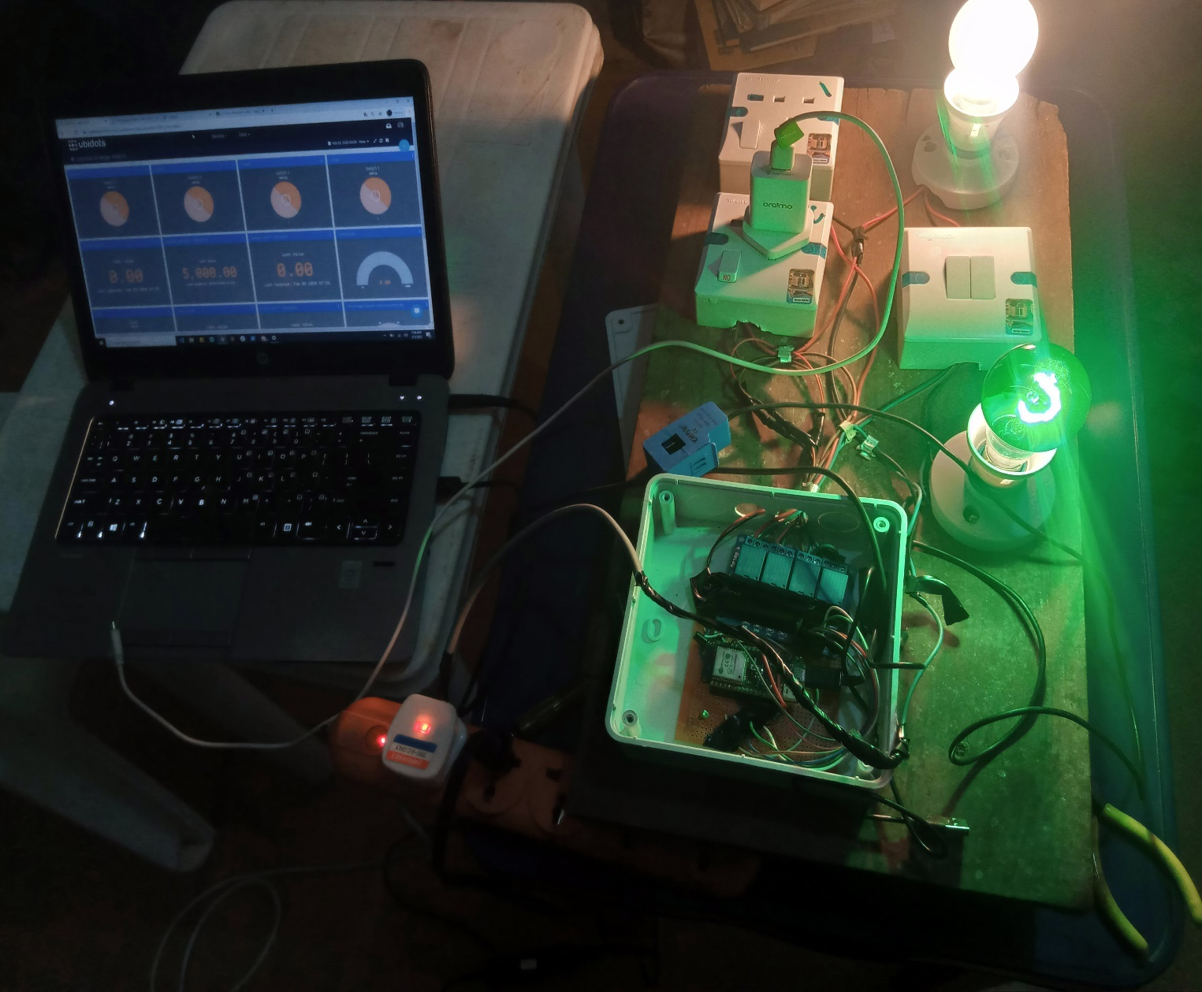

**Fig 4.1:** The testing phase of the project featuring the dashboard

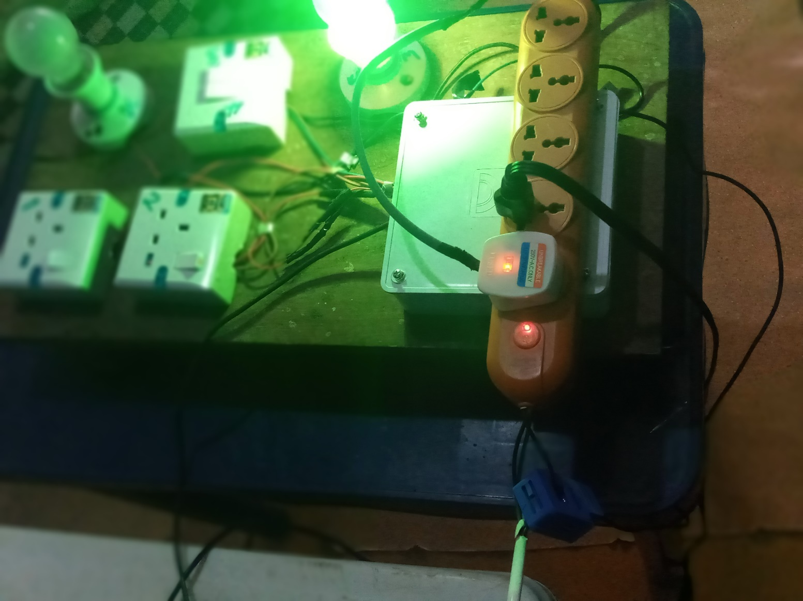

**Fig 4.2**: The final hardware system featuring the current sensor in use

## 4.2 The Web Application

The web application was completely built with web technologies enhanced with **Ubidots** platform which provided several tools out of the box including data visualization and notification alerts. So, it consists of 3 parts of which 2 worked perfectly fine while the last (notification system) was still behaving randomly mostly because it was an add-on provided by **Ubidots** and thus limited control for free tier.

The dashboard successfully issues control command to the loads via internet while also receiving data such as power, energy and cost readings and displaying it.

It is worth mentioning that the communication is not asynchronous and so commands might be delayed at times if one has not finished executing. Also, it largely depends on good internet connection and communication might not be totally effective in a poor network environment.

Fig 4.3a and 4.3b shows signup and login page of the web app, fig 4.4 shows the dashboard and fig 4.5 shows graphical visualization of previous data recorded.

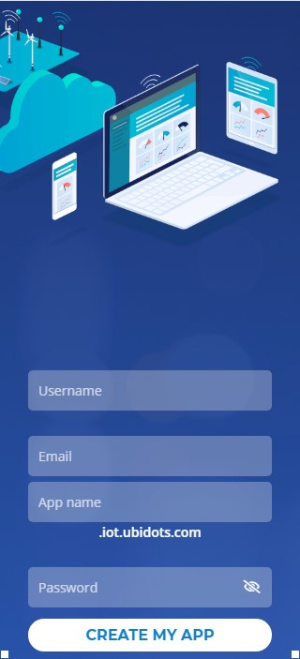 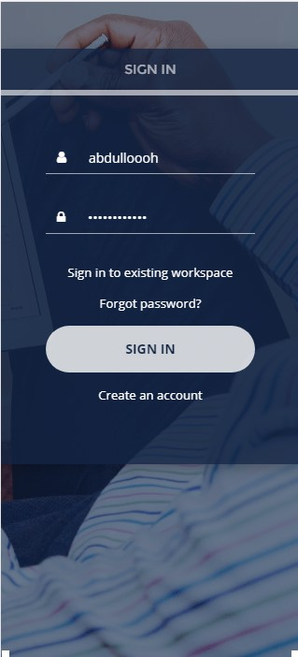

1. (b)

**Fig 4.3 (a)** Signup page and **(b)** Login page

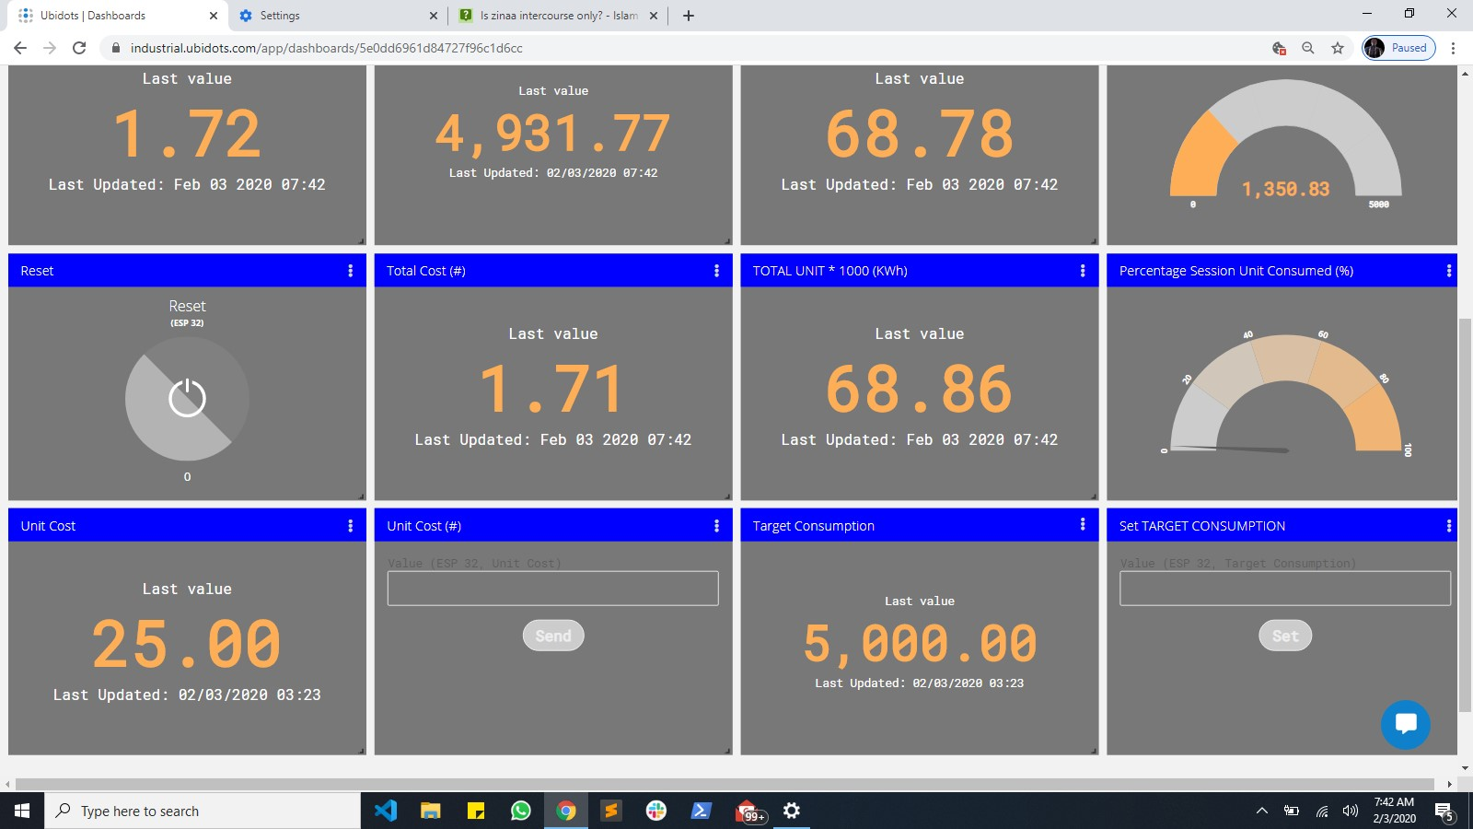

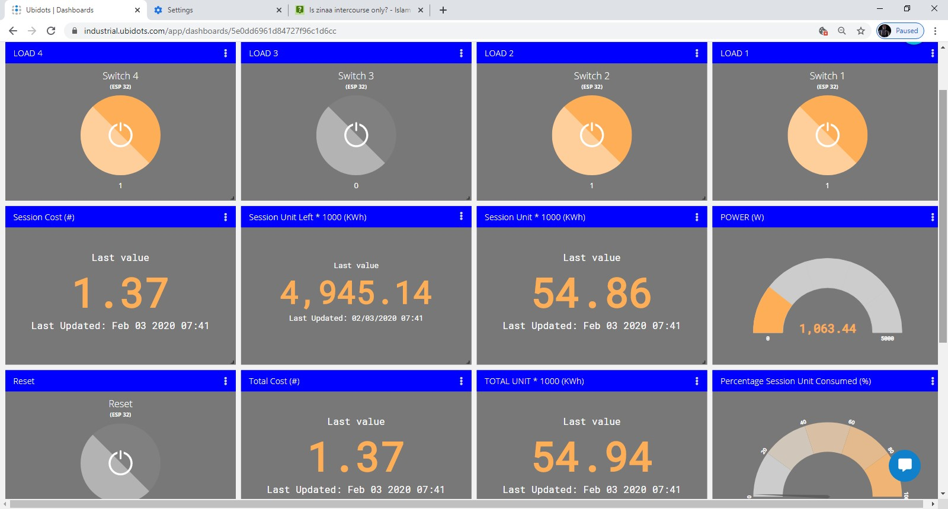

**Fig 4.4:** Dashboard

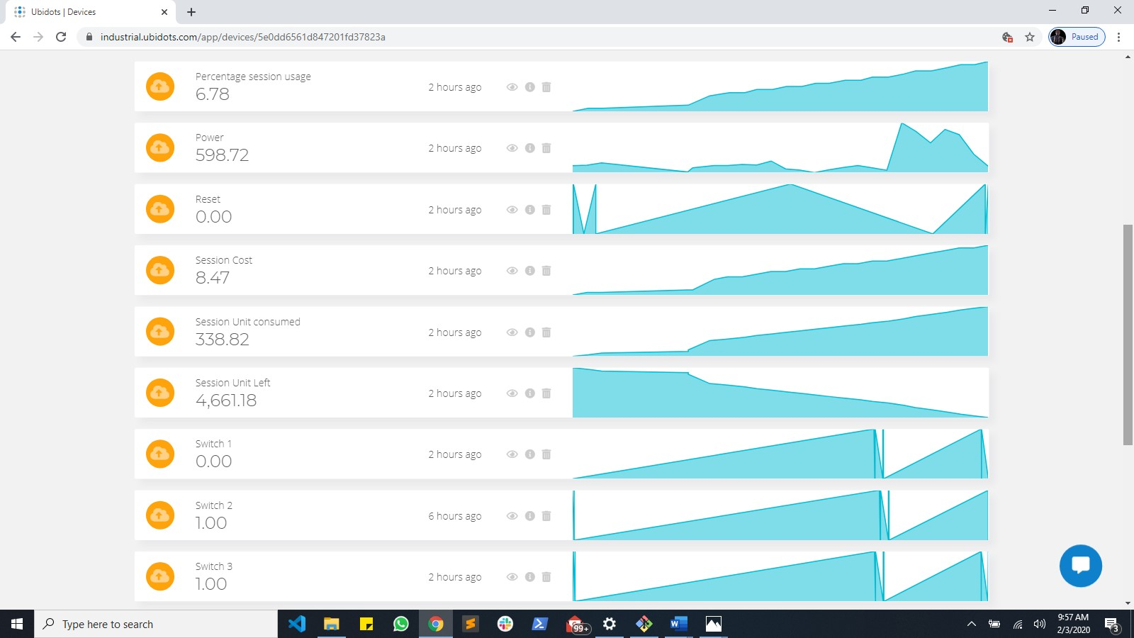

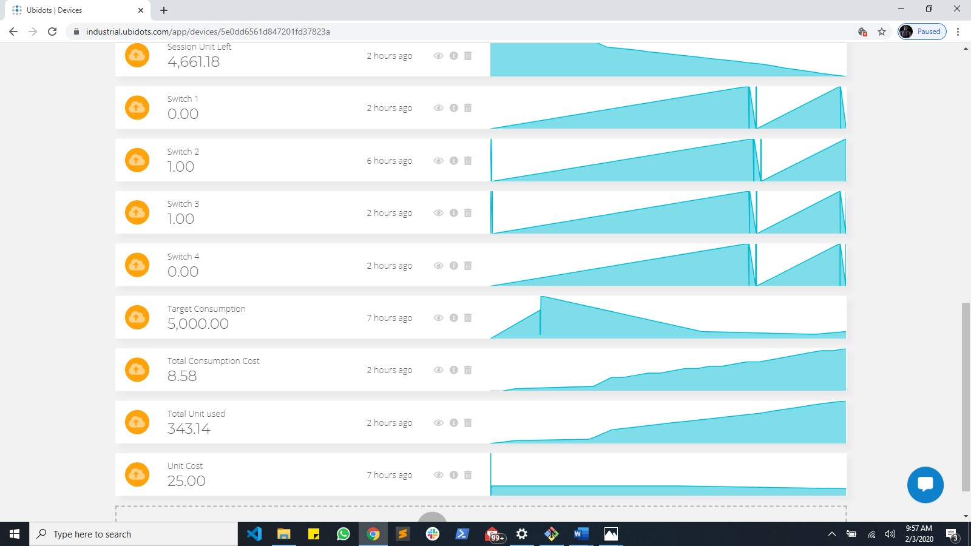

**Fig 4.5:** Data log

## 4.3 Summary

The project was a success and the objectives were met; loads can easily be controlled anywhere, energy consumption can be tracked, cost can be made more effective and data gathered over time can be visualised and also used for more advanced purpose like artificial intelligence and machine learning. This project comes with its setbacks and inaccuracies discussed in chapter 5 but overall, it is absolutely a great progress into digitalization and standard smart home.

# 

# CHAPTER 5

# CONCLUSION

## 5.1 Conclusion

This design and implementation of smart energy meter with load control has proven that energy consumption can easily be monitored and managed either for a building as a whole or for different sections of a building, thereby increasing the ease of estimating exact consumption of a facility while increasing energy efficiency and conservation at minimum cost possible.

This project also gives user the flexibility and ease of controlling his home from anywhere so he would not have to stress on being around his facility before he can control an appliance likewise an advantage for the disabled.

Thus, the objectives of this project were met.

## 5.2 Recommendation

Although this project meets the objectives set, it is still important to know that “no matter the level of achievement, there is always room for improvement”. Thus, to improve on this project and make it more accurate and efficient; the following are recommended:

* Current sensor of lower rating (e.g. 30A) should be considered for low current application and vice versa while also taking note of scalability.
* Use of more accurate current sensor should be considered for accuracy-demanding application (trade-off is cost)
* The dashboard should be completely built with no third-party plugin to improve accuracy, security, flexibility and absolute control over the system.
* In a poor internet network environment, device that can provide 2G network such as SIM-800 or SIM-900 module should be considered for effective communication of controller and dashboard.
* Solid state relay should be considered for efficient and fast switching of loads.

# REFERENCES

Amin, S. M., and Wollenberg, B. F. (2005). Toward a smart grid: power delivery. *IEEE Power and Energy Magazine*, vol. 3, no. 5,pp. 34-41.

Baig, I., Muzamil, C., and Dalvi, S. (2015-2016). Home automation using arduino WiFi Module ESP8266. *Final year project Thesis*. Anjuman-i-islam's Kalsekar Technical Campus, Panvel, India.

*Best Home Automation Products*. (2020, 01 30). Retrieved from safety.com: https://www.safety.com/best-home-automation-products/

Bhat, O., Bhat, S., and Gokhale, P. (2017). Implementation of IoT in Smart Homes . *International Journal of Advanced Research in Computer and Communication Engineering* , 1.

Chooruang, K., and Meekul, K. (2019). Design of an IoT Energy Monitoring System. *2018 Sixteenth International Conference on ICT and Knowledge Engineering*, 1.

*CT Sensors*. (n.d.). Retrieved from Open Energy Monitor: https://learn.openenergymonitor.org/electricity-monitoring/ct-sensors/introduction?redirected=true

*Current sensor*. (2019, January). Retrieved from Wikipedia: en.m.wikipedia.org/wiki/Current_sensor; retrieved: July, 8, 2019

Deep, A. (n.d.). *Hackernoon*. Retrieved from Mobile Apps as IoT Core: Exploring the Connection: https://hackernoon.com/mobile-apps-as-iot-core-exploring-the-connection-9fcdc2eeefcbe?gi=d98e609ec848, retrieved: July 1, 2019

*Home automation*. (2019, June 27). Retrieved from Wikipedia: https://en.wikipedia.org/wiki/Home_automation, retrieved: June 30, 2019

*Internet of things*. (2019, June 20). Retrieved from Wikipedia: https://en.wikipedia.org/wiki/Internet_of_things, retrieved: June 30, 2019

*Internet Stats and Facts for 2019*. (2018, 12 17). Retrieved from hostingfacts: https://hostingfacts.com/internet-facts-stats/

Maier, A., Sharp, A., and Vagapov, Y. (2017). Comparative Analysis and Practical Implementation of the ESP32 Microcontroller Module for the Internet of Things. *IEEE Journal*, 2.

Mates, M. (2020, 01 13). *Containerized builds for Rust on the ESP32*. Retrieved from dev.to: https://dev.to/mtnmts/containerized-builds-for-rust-on-the-esp32-e8m

Morris, M. (2017, June 14). *security concerns in mobile app*. Retrieved from topcoder: www.topcoder.com/blog/security-crowdsourcing-vs-traditional-software-dev/

Mwaura, W. (2018, December 12). *Why the internet of things is the real deal*. Retrieved from Medium.com: https://medium.com/the-andela-way/why-iot-is-the-real-deal-97ae8f66ce5f, retrieved: June 30, 2019

Patnaikuni, D. R. (2017). A Comparative Study of Arduino, Raspberry Pi and ESP8266 as IoT Development Board. *International Journal of Advanced Research in Computer Science*, Volume 8, No. 5.

Starr, D. (2020, 01 30). *Best Home Automation Products*. Retrieved from safety.com: https://www.safety.com/best-home-automation-products/

Stroud, F. (n.d.). *smart home*. Retrieved from webopedia: https://www.webopedia.com/TERM/S/smart-home.html, retrieved: June 30, 2019

Taktak, E., and Rodriguez, I. B. (2017). Energy Consumption Adaptation. *2017 IEEE/ACS 14th International Conference on Computer Systems and Applications (AICCSA)*, pp. 1370-1377.

Vagapov, Y., Maier, A., and Sharp, A. (2017). Comparative Analysis and Practical Implementation of the ESP32 Microcontroller Module for the Internet of Things. *IEEE* (p. p1). Researchgate.

*What are Motion Sensors And How Do They Work*. (2018). Retrieved from EL-PRO-CUS: www.elprocus.com/working-of-different-types-of-motion-sensors/; retrieved: July 8, 2019